Date: 25/07/25
Roll No. and Name: 24BCE180 and Priyansh Patel
Course Code and Name: 2CS502CC25 and Object Oriented Programming
Practical No: 3(a)
AIM: Create overloaded functions named 'area' to compute the area
of a circle, rectangle, and triangle

Methodology followed:
#include <iostream>
#include <cmath>
using namespace std;

double area(double radius) {
return 3.14 * radius * radius;
}

double area(double length, double width) {
return length * width;
}

double area(double a, double b) {
return 0.5*a*b;
}

int main() {
cout<<"Which area do you want to calculate?"<<endl;
cout<<"1. Circle"<<endl<<"2. rectangle"<<endl<<"3. triangle"<<endl;
int choice;
cin>>choice;

if(choice==1){
double radius;
cout<<"Enter the radius of the circle: ";
cin>>radius;
cout << "Area of circle : " << area(radius) << endl;
}

if(choice==2){
double length, width;
cout<<"Enter the length of the rectangle: ";
cin>>length;
cout<<"Enter the width of the rectangle: ";
cin>>width;
cout << "Area of rectangle : " << area(length, width) << endl;
}

if(choice==3){
double h, b;
cout<<"Enter the base of the triangle: ";
cin>>b;
cout<<"Enter the height of the triangle: ";
cin>>>h;
cout << "Area of triangle : " << area(a, h) << endl;
}
else{
cout<<"Choose valid number[1 to 3]!!! "<<endl;
}
return 0;
}

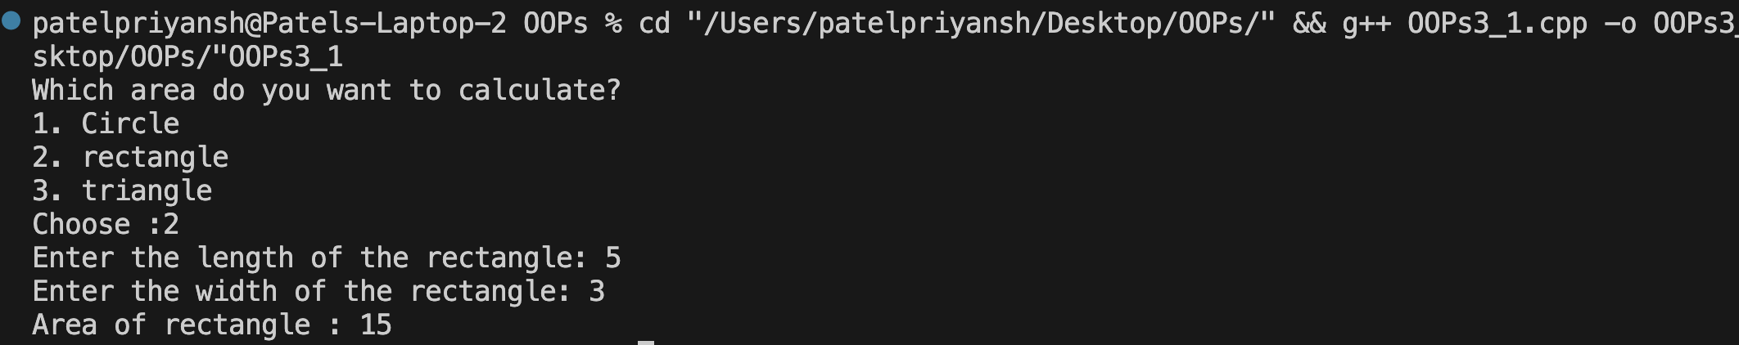
Output:

Practical No: 3(b)
AIM: Develop an inline function that returns the cube of a number
and use it with user input.

Methodology followed:
#include <bits/stdc++.h>
using namespace std;
inline long long cube(long long a){
return a*a*a;
}
int main() {
int a;
cout<<"Enter number :";
cin>>a;
cout<<"Cube of "<<a<<" is "<<cube(a);
return 0;
}
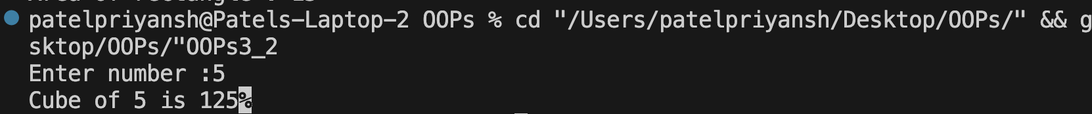
Output:

Practical No: 3(c)
AIM: Write overloaded 'display' functions that print an integer, a
float, and a string respectively.

Methodology followed:
#include <bits/stdc++.h>
using namespace std;

void display(int num){
cout<<"Integer :"<<num<<endl;
}

void display(float num){
cout<<"Float :"<<num<<endl;
}

void display(string s){
cout<<"String :"<<s<<endl;
}

int main() {
int num;
cout<<"Enter integer number :";
cin>>num;
float num1;
cout<<"Enter float number :";
cin>>num1;
string s;
cout<<"Enter string :";
cin>>s;
display(num);
display(num1);
display(s);

return 0;
}
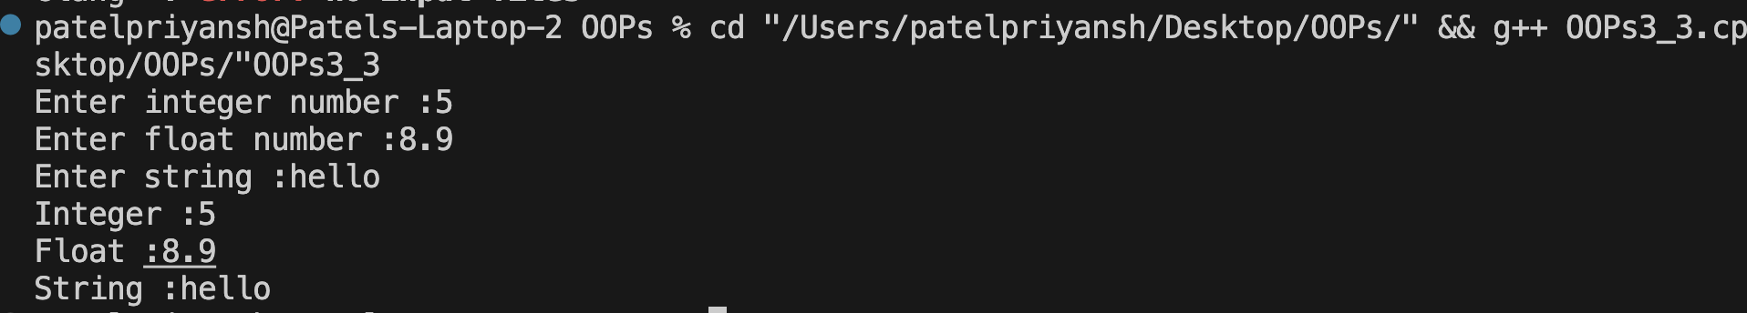
Output:

Practical No: 3(d)
AIM: Create a program that uses inline functions to return the
maximum of two numbers.

Methodology followed:
#include <bits/stdc++.h>
using namespace std;

inline float max(float a,float b){
if(a>b) return a;
else return b;
}
int main() {
float a,b;
cout<<"Enter first number :";
cin>>a;
cout<<"Enter second number :";
cin>>b;
cout<<"Max number is "<<max(a,b)<<endl;
return 0;
}
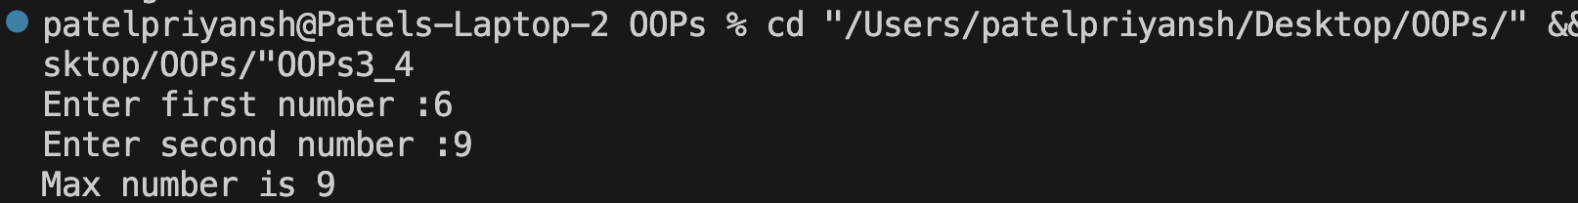
Output:

Practical No: 3(e)
AIM: Develop a program that uses function overloading for
summing two and three double values.
Methodology followed:
#include <bits/stdc++.h>
using namespace std;

void sum(double a,double b){
cout<<"Sum of first two number is "<<a+b<<endl;
}
void sum(double a,double b,double c){
cout<<"Sum of three number is "<<a+b+c<<endl;
}

int main() {
int a,b,c;
cout<<"Enter all three number :";
cin>>a>>b>>c;
sum(a,b);
sum(a,b,c);
return 0;
}
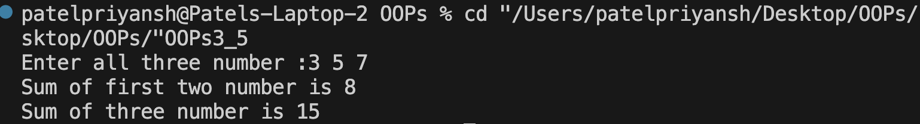
Output:
Conclusion:
This practical helped us understand function overloading and inline functions in C++. These concepts improve code readability, reusability, and performance in modular programming.

